SIMATS ENGINEERING (SAVEETHA SCHOOL OF ENGINEERING)
Department of Computer Science and Engineering
CO4 ASSESSMENT TOOL 2 – CI/CD Pipeline Design Exercise

Course Code: | CSA10 / CSA1063 | Course Title: | Software Engineering
CO Assessed: | CO4 | Assessment: | Assessment Tool 2 – CI/CD Pipeline Design Exercise
Weightage: | 20% | Total Marks: | 25
CO4 Statement: | Implement robust testing, quality assurance, and DevOps practices, emphasizing security, reliability, and ethics
Student Name: | Ramana Y | Reg. No.: | 192525476
Date: |  | Duration: | 60 minutes

Code of Conduct
I Ramana Y (192525476) certify that this submission is my original work and that I have adhered to the guidelines specified for this assessment. I understand that any violation of academic integrity rules will result in disciplinary action.
Signature of the Student: _________________________
Annexure A – CI/CD Pipeline Design Exercise
Instructions to Students:
Each student is assigned an individual problem statement. Based on the assigned problem statement, design a CI/CD (Continuous Integration and Continuous Deployment) pipeline for the proposed software system to automate the processes of code integration, building, testing, and deployment.
The exercise should include:
- Analyze the project requirements and identify the CI/CD needs of the assigned problem statement.
- Design the CI/CD pipeline workflow showing stages such as source code management, build, testing, code quality analysis, packaging, and deployment.
- Identify suitable tools and technologies for each stage of the pipeline and justify their selection.
- Define appropriate automated testing strategies to be integrated into the pipeline.
- Design the deployment strategy, including development, testing/staging, and production environments.
- Incorporate appropriate security, quality checks, notifications, and rollback mechanisms in the pipeline.
- Prepare a CI/CD pipeline diagram and explain the workflow from code commit to deployment.
Deliverable: Submit a CI/CD Pipeline Design document containing the pipeline architecture/diagram, stages, tools, configuration/workflow, testing strategy, deployment process, and justification based on the assigned problem statement.

Rubrics for Calculation
Evaluation Criteria | Excellent (4 Marks) | Good (3 Marks) | Satisfactory (2 Marks) | Needs Improvement (1 Mark)
Requirement & Pipeline Analysis(15%) | Clearly analyzes the assigned problem and identifies comprehensive CI/CD requirements | Identifies most relevant requirements | Identifies basic requirements with some gaps | Requirements are unclear or incomplete
Pipeline Architecture & Workflow(25%) | Designs a complete, logical pipeline covering source, build, test, quality check, package, and deployment stages | Pipeline covers most major stages with minor gaps | Basic pipeline is designed but several stages are missing | Pipeline is incomplete or poorly structured
Tools & Technology Selection(20%) | Selects appropriate tools for each stage and provides clear justification | Appropriate tools selected with reasonable justification | Tools are identified but justification is limited | Tools are inappropriate or not clearly identified
Automated Testing & Quality Integration(15%) | Effectively integrates automated testing and code-quality/security checks into the pipeline | Includes major testing and quality checks | Includes basic testing with limited integration | Testing/quality checks are missing or inappropriate
Deployment, Security & Rollback Strategy(15%) | Clearly designs deployment environments, security practices, monitoring, and rollback strategy | Covers deployment and most security/rollback aspects | Basic deployment strategy with limited security/rollback details | Deployment strategy is incomplete or lacks security considerations
Pipeline Diagram & Documentation(10%) | Clear, accurate, professional diagram with excellent explanation and documentation | Well-presented diagram and documentation with minor issues | Adequate diagram/documentation but lacks clarity | Poorly presented, incomplete, or difficult to understand

Criteria | Mark
Requirement & Pipeline Analysis(15%) | /5
Pipeline Architecture & Workflow(25%) | /4
Tools & Technology Selection(20%) | /4
Automated Testing & Quality Integration(15%) | /4
Deployment, Security & Rollback Strategy(15%) | /4
Pipeline Diagram & Documentation(10%) | /4
TOTAL | /25

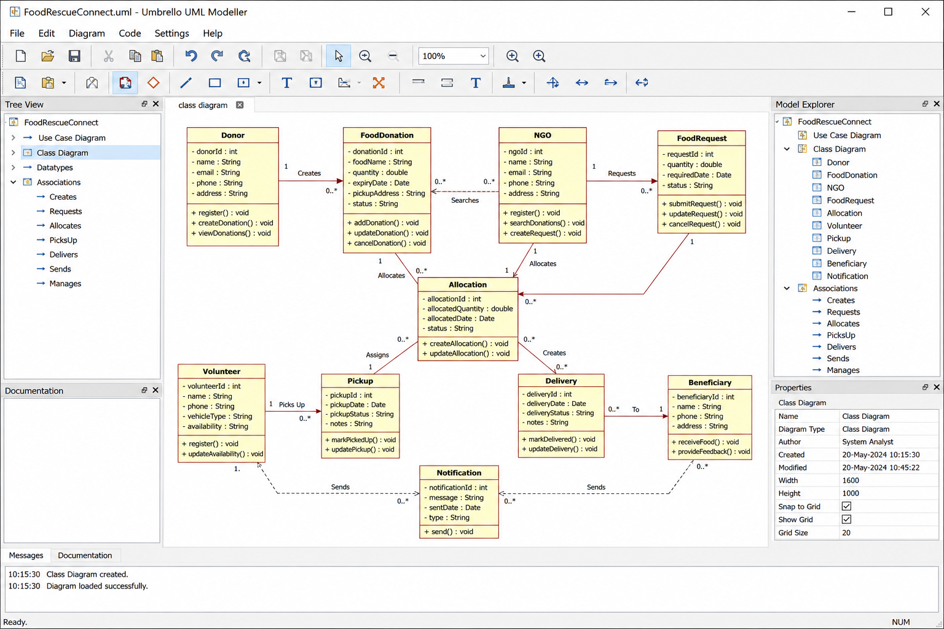

1. Project and CI/CD Requirement Analysis
The assignment requires a CI/CD pipeline that automates code integration, building, testing and deployment. For FoodRescue Connect, the pipeline must support a system with multiple modules such as user management, food donation, request and allocation, AI recommendation, route optimization, tracking, notifications and analytics.

1.1 CI/CD Needs
Need | FoodRescue Connect Requirement | CI/CD Response
Frequent integration | Multiple modules and developers may change independently. | Git branching, pull requests and automated CI.
Automated build | Backend, frontend and service components must be packaged consistently. | Repeatable build stage.
Automated testing | Donation, allocation, tracking and API logic require continuous validation. | Unit, integration, API and end-to-end tests.
Quality control | Incorrect or insecure code can affect food allocation and user data. | Linting, static analysis and security scanning.
Reliable deployment | Production service must remain available. | Staging validation, health checks and controlled release.
Fast recovery | A failed release should not interrupt service for long. | Versioned images and rollback to last known-good release.
Security | System handles accounts, locations and operational data. | Secret management, dependency scanning and least privilege.
Observability | Failures in services, maps, notifications or deployment must be visible. | Central logs, metrics, alerts and deployment notifications.

1.2 Quality and Operational Goals
- Scalability: allow individual application services to scale as usage grows.
- Reliability: detect failed builds, tests and deployments before release.
- Availability: use health checks and controlled deployment to reduce downtime.
- Maintainability: keep source, tests, configuration and deployment definitions version-controlled.
- Security: prevent secrets and vulnerable dependencies from entering the release.
- Performance: include automated tests and monitoring so regressions can be detected early.

2. Proposed CI/CD Pipeline Architecture
A pipeline combining Git-based Continuous Integration, automated quality gates, container packaging and staged deployment is proposed. The design is suitable for the FoodRescue Connect application because it separates development, validation and production release activities while making every release traceable to source code.
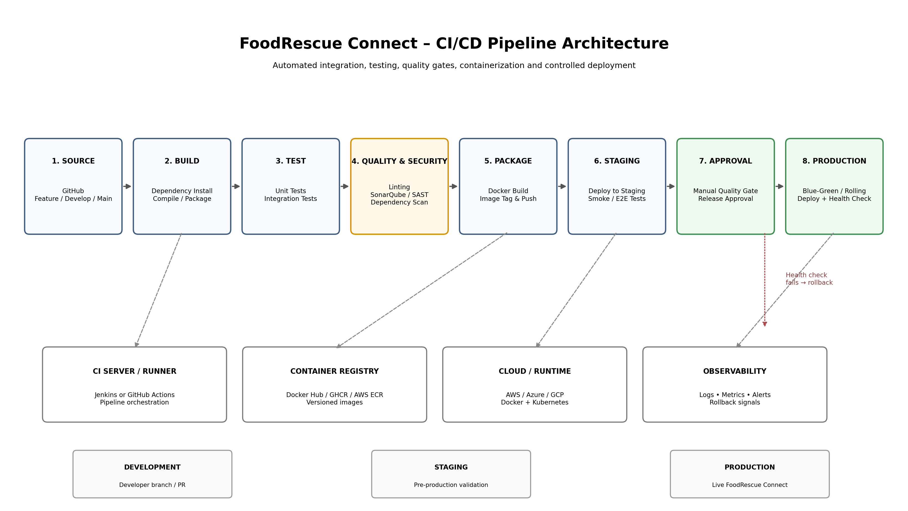
Figure 1. FoodRescue Connect CI/CD Pipeline Architecture

2.1 Pipeline Flow
Developer → Git repository → CI trigger → Build → Unit tests → Integration/API tests → Code quality & security checks → Docker image build → Container registry → Staging deployment → Smoke/E2E tests → Approval gate → Production deployment → Health checks → Monitoring → Rollback if required.

3. Pipeline Stages
Stage | Main Activities | Output / Gate
1. Source Code Management | Developer commit, branch, pull request, code review. | Reviewed commit ready for CI.
2. Build | Install dependencies, compile/package application. | Build artifact / package.
3. Automated Testing | Unit, integration, API and selected E2E tests. | All mandatory tests pass.
4. Quality & Security | Linting, static analysis, SAST, dependency and secret checks. | Quality/security gate passes.
5. Package | Build Docker image, tag with version/commit, push to registry. | Immutable versioned image.
6. Staging | Deploy exact image to staging environment. | Staging deployment successful.
7. Validation | Smoke tests, E2E tests and health checks. | Release candidate validated.
8. Approval | Manual approval for production where required. | Authorized release.
9. Production | Rolling or blue-green deployment. | Live release.
10. Monitor & Rollback | Observe health, logs and metrics; revert on failure. | Stable production version.

4. Tools and Technology Selection
The following tools are proposed for the pipeline. These are design choices for the exercise; the assignment source requires tool identification and justification but does not prescribe particular products.
Pipeline Area | Proposed Tool | Justification
Source control | Git + GitHub | Version history, branching, pull requests and collaboration.
CI/CD orchestration | Jenkins | Flexible pipeline-as-code and integration with build/test/deployment tools.
Application packaging | Docker | Consistent runtime environment from development through production.
Container registry | GitHub Container Registry (GHCR) | Stores versioned container images close to source repository.
Unit testing | Pytest / JUnit | Automates component-level validation depending on service language.
API testing | Postman/Newman | Automates REST API regression tests.
Code quality | SonarQube | Static analysis and maintainability/quality gates.
Security | OWASP Dependency-Check + SAST | Detect vulnerable dependencies and common code-level risks.
Runtime | Docker / Kubernetes | Container execution and scalable service deployment.
Cloud | AWS / Azure / GCP | Managed infrastructure, networking, monitoring and deployment options.
Notifications | Email / Teams / Slack webhook | Fast feedback on pipeline success or failure.
Monitoring | Prometheus + Grafana | Metrics, dashboards and alerting for deployed services.

5. Branching and Source Control Strategy
- main: production-ready code only.
- develop: integrated development branch for the next release.
- feature/*: short-lived branches for individual features or fixes.
- Pull requests: mandatory review and automated CI before merge.
- Release tags: identify the exact production version and Docker image.
- Hotfix/*: urgent production fixes that follow the same automated quality gates.
Recommended rule: a pull request cannot be merged when mandatory tests or quality/security gates fail. This prevents known defects from entering the shared release branch.

6. Automated Testing and Quality Integration
Test Layer | Examples for FoodRescue Connect | Pipeline Point
Unit testing | Donation validation, quantity validation, allocation logic, route helper functions. | After build
Integration testing | Service-to-database, service-to-service and event/message interactions. | After unit tests
API testing | Login, donation creation, food request, allocation, tracking APIs. | CI / staging
End-to-end testing | Donor creates donation → NGO requests → volunteer pickup → delivery. | Staging
Security testing | Authentication, authorization, dependency and secret checks. | Quality/security gate
Smoke testing | Application starts, key endpoints respond, database connection works. | Immediately after staging/prod deployment
Performance testing | Critical API response and load behavior. | Scheduled / release pipeline

6.1 Quality Gates
- Build must complete successfully.
- Mandatory unit and integration tests must pass.
- API regression tests must pass for critical services.
- No critical security vulnerability should be accepted into production.
- Static-analysis quality gate must meet the project threshold.
- Container image must be successfully built and stored with an immutable version tag.
- Staging smoke/E2E tests must pass before production approval.

7. Deployment Strategy
Environment | Purpose | Deployment Rule
Development | Developer integration and early validation. | Automatic deployment from development branch where appropriate.
Staging / Testing | Production-like environment for release validation. | Automatic after CI gates pass.
Production | Live FoodRescue Connect system. | Controlled deployment after staging validation and approval.

7.1 Recommended Release Strategy
A rolling deployment can be used for routine releases, while blue-green deployment can be used when stronger rollback is required. The pipeline should deploy a versioned image, run health checks, and keep the previous stable image available.

8. Security, Monitoring and Rollback

8.1 Security Controls
- Store credentials, API keys and tokens in a secret manager or protected CI/CD credentials store.
- Never commit passwords, API keys or production secrets to Git.
- Use least-privilege permissions for CI runners and deployment accounts.
- Scan application dependencies and source code before packaging.
- Scan container images for known vulnerabilities.
- Use HTTPS/TLS for application and deployment endpoints.
- Restrict production deployment permissions to authorized users/jobs.

8.2 Monitoring and Notifications
- Record build, test and deployment logs.
- Monitor application health, CPU/memory, error rates and response time.
- Generate alerts when a production health check fails.
- Notify the development team when a build, test, security gate or deployment fails.
- Track deployment version so failures can be correlated with a specific commit/image.

8.3 Rollback Strategy
- Every production deployment uses a unique image/version tag.
- After deployment, run automated health and smoke checks.
- If health checks fail, stop or reverse the rollout.
- Redeploy the previous known-good image.
- Record the failed release and notify the responsible team.
- Create a follow-up defect/hotfix before attempting the release again.

9. CI/CD Workflow Example
Step | Action | Expected Result
1 | Developer creates feature branch | feature/donation-validation
2 | Code is committed and pushed | Git repository receives commit
3 | Pull request is created | Review + CI trigger
4 | Build stage executes | Dependencies installed and application built
5 | Automated tests execute | Unit + integration + API tests
6 | Quality/security gate executes | Lint + static analysis + vulnerability scans
7 | Docker image is created | Image tagged with release/commit
8 | Image is pushed to registry | Versioned artifact available
9 | Staging deployment | Same image deployed to staging
10 | Smoke/E2E validation | Release candidate verified
11 | Production approval | Authorized release decision
12 | Production deployment | Rolling/blue-green release
13 | Health check + monitoring | Stable release confirmed or rollback

10. Pipeline Configuration Example
The following simplified Jenkins-style pipeline illustrates the intended workflow. It is a design example, not a complete production configuration.
pipeline {
agent any
stages {
stage('Checkout') {
steps { checkout scm }
}
stage('Build') {
steps { sh 'docker build -t foodrescue:${BUILD_NUMBER} .' }
}
stage('Unit Tests') {
steps { sh 'pytest tests/unit' }
}
stage('Integration & API Tests') {
steps { sh 'pytest tests/integration' }
}
stage('Quality & Security') {
steps {
sh 'sonar-scanner'
sh './security-scan.sh'
}
}
stage('Package & Push') {
steps {
sh 'docker push foodrescue:${BUILD_NUMBER}'
}
}
stage('Deploy Staging') {
steps { sh './deploy-staging.sh' }
}
stage('Staging Validation') {
steps { sh './smoke-and-e2e-tests.sh' }
}
stage('Production Approval') {
steps { input 'Deploy to production?' }
}
stage('Deploy Production') {
steps { sh './deploy-production.sh' }
}
stage('Health Check') {
steps { sh './health-check.sh' }
}
}
post {
success { echo 'Pipeline completed successfully' }
failure { echo 'Pipeline failed - investigate and rollback if required' }
}
}

11. Failure Handling Scenarios
Failure | Pipeline Response | Recovery
Compilation/build failure | Stop pipeline. | Developer fixes code and pushes a new commit.
Unit test failure | Do not package/deploy. | Fix failing test or implementation.
Security gate failure | Block release. | Resolve vulnerability or approved exception.
Docker build failure | Stop packaging stage. | Correct Dockerfile/dependencies.
Staging deployment failure | Block production. | Investigate deployment/configuration.
Staging E2E failure | Block production. | Fix application or integration defect.
Production health-check failure | Stop rollout / rollback. | Restore previous stable release.
External service failure | Alert and monitor. | Retry/fallback according to application design.

12. CI/CD Benefits to FoodRescue Connect
- Reduces manual deployment effort and human configuration errors.
- Detects defects earlier through automated testing.
- Improves release consistency by packaging the application as a versioned container.
- Provides traceability from production deployment back to source code.
- Improves security by adding automated quality and vulnerability checks.
- Supports frequent updates to AI, donation, notification, tracking and analytics modules.
- Enables safer releases through staging validation, health checks and rollback.
- Creates a repeatable process that can scale as FoodRescue Connect expands.

13. Architectural and Technical Justification
The proposed pipeline is intentionally organized around automated gates. Source control provides traceability; build and test stages establish correctness; quality and security checks prevent known issues from moving forward; containerization ensures consistent deployment artifacts; staging provides a production-like validation point; and controlled production deployment with health checks and rollback reduces operational risk.
The main trade-off is additional tooling and pipeline complexity compared with manual deployment. However, the assignment focuses on robust testing, quality assurance and DevOps practices, and the additional automation provides stronger repeatability, security and reliability. fileciteturn1file0L9-L11

14. Conclusion
The proposed FoodRescue Connect CI/CD pipeline automates the complete path from source-code commit to validated production deployment. It includes source control, build, automated testing, quality and security checks, Docker packaging, staging validation, controlled production deployment, monitoring and rollback. The design directly addresses the assignment's required pipeline stages, automated testing, deployment environments, security, notifications and rollback mechanisms. fileciteturn1file0L24-L38
This approach provides a practical foundation for a maintainable and reliable software delivery process while allowing FoodRescue Connect to evolve as new features, integrations and services are introduced.
